MINISTRY OF TRANSPORT, INFRASTRUCTURE, HOUSING, URBAN DEVELOPMENT AND PUBLIC WORKS
STATE DEPARTMENT FOR TRANSPORT
AIR ACCIDENT INVESTIGATION DEPARTMENT

PRELIMINARY REPORT

OPERATOR/OWNER : Loisaba Conservancy Trust
AIRCRAFT TYPE/ MANUFACTURER : Piper PA-18A Super Cub/Piper Aircraft Company
YEAR OF MANUFACTURE : 1960
AIRCRAFT REGISTRATION : 5Y-BAU
AIRCRAFT SERIAL NUMBER : 28-7690294
DATE OF REGISTRATION : 17 October 2016
NUMBER AND TYPE OF ENGINE : One Lycoming O-320-B2B
ENGINE SERIAL NUMBER : RL-8215-39E
DATE OF OCCURRENCE : 10 June 2019
TIME OF OCCURRENCE : 1007 hours
LOCATION OF OCCURRENCE : Loisaba (00°37.819ˈN 036°47.487ˈE)
TYPE OF FLIGHT : Training
PHASE OF FLIGHT : Descend
NUMBER OF PERSONS ON BOARD : Two (2)
INJURIES : None
NATURE OF DAMAGE : Substantial structural damage
CATEGORY OF OCCURRENCE : Accident
PILOT IN COMMAND (PICUS) : PPL-holder
PICUS’s FLYING EXPERIENCE : 1207.8 hours
CHECK PILOT (CP) : CPL – holder
CP’s FLYING EXPERIENCE : 1968 hours

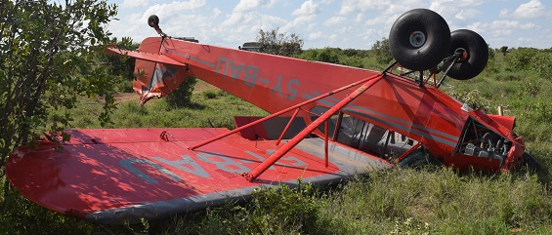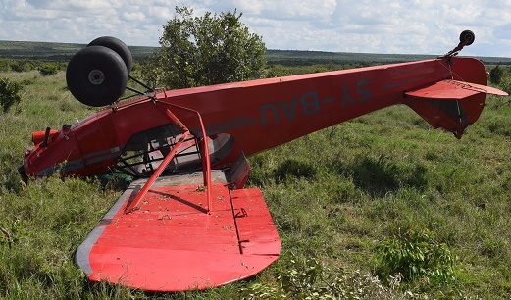
REMARKS
On 10 June 2019 at approximately 1100, the Aircraft Accident Investigation Department (AAID) was notified of an accident at Loisaba Conservancy in Lainkipia by the Air Traffic Services. The accident involved a Piper PA-18A Super Cub of registration 5Y-BAU operated by Loisaba Conservancy Trust. The aircraft crashlanded on an open field approximately 0.8NM from Loisaba Airstrip following loss of engine power.
On 10 June 2019, 5Y-BAU had been scheduled to conduct a training flight at the Loisaba Conservancy for the purpose of checking out a prospective pilot. The Check Pilot (CP) had accumulated about 1500 hours on the Piper PA-18 Super Cub and was identified for the role by organization based on his experience on type. The flight was delayed by prevailing light showers in the morning. The pilots reported that as they waited on the weather to improve, they conducted a familiarization walk around, review of the aircraft systems and a preflight inspection. At approximately 0830, 5Y-BAU took off for a refresher flight for the CP, who had not flown the PA-18 Super Cub for about a year and needed to better familiarize himself with this particular aircraft. The CP was the PICUS on this refresher flight and was accompanied by another supervising pilot who was more current on the type. After the refresher flight that lasted about 20 minutes without event and included two touch and go landings, two crosswind landings and one final full stop landing, the CP reported that he was at that point comfortable with the Super Cub and was ready to check out the PICUS.
At approximately 0900, flight preparations were initiated for the second flight with PICUS seated at the front and the CP seated at the back. The pilots reported that they once again reviewed the different systems in the airplane and location of switches and gauges. According to the pilots, they had 36 US Gallons of fuel on both tanks. Engine power runs were reported to have been conducted prior to the flight and all parameters were within range. The engine was reported to have been running fine. 5Y-BAU took off at 0920 and according to the pilots, they conducted steep turns at 800 feet AGL, a power stall at 1000 feet AGL, six landings and six takeoffs on runway 07, 25 and 16. The flight was generally uneventful and the pilots reported that they were conducting wide circuits to give the PICUS adequate time to slow the aircraft down and execute a steady approach. During the extended base leg for landing on runway 16 while flying at an altitude of 200 feet AGL, the PICUS put the first notch of 10° flaps and trimmed the airplane nose down. This was subsequently followed by the second notch of 10° flaps and further nose down trim. The pilots then reported that they noticed the aircraft had suddenly lost power and they were losing altitude. At this point, the aircraft was reported to have been flying at a heading of 270° and the engine was already at low power in readiness for landing. The pilots reported that they checked the fuel selector and it was in the ‘Both’ position. They also reported that the engine did not respond when they pushed mixture control to the full rich position and with the throttle opened full. The engine was now reported to have been completely shut down with only the propeller wind milling at the front. The CP took control of the aircraft, identified an open landing field ahead and glided towards it. The aircraft touched down on both main wheels, rolled over an ant hill, hit some shrubs and flipped over to facing a heading of about 155°SE. The heading at touchdown and ground roll was approximately 300°NW. The aircraft came to rest at position 00°37.819ˈN 036°47.487ˈE and at an elevation of 5640 feet AMSL. The aircraft rolled on the ground for 400 feet before coming to rest. The shrubs hit by the aircraft were located 60 feet from the final resting point.
The pilots reported that after the crash, they noticed that the magneto switches were in the off position. The location of the trim handle and magneto switches on 5Y-BAU were in close proximity.
The aircraft sustained substantial structural damage as a result of this accident. There were no injuries reported.
The safety investigation is in progress.

Rufus Mutwol
Investigator-In-Charge

