MINISTRY OF TRANSPORT AND INFRASTRUCTURE
STATE DEPARTMENT OF TRANSPORT
AIR ACCIDENT INVESTIGATION

TRANSCOM BUILDING
NGONG ROAD
P.O. Box 52592 - 00100
NAIROBI

Telegrams: “TRANSCOMS”. Nairobi
Telephone: (020) 2729200
Email: info@transport.go.ke
Website: www.transport.go.ke

FINAL ACCIDENT REPORT 5Y-BZQ 13.01.2014

This investigation was carried out in accordance with Annex 13 to the Convention on International Civil Aviation; it is not the purpose of aircraft accident investigation to apportion blame or liability. The sole objective of the investigation and the Final Report is the prevention of accidents and incidents.

ACCIDENT SUMMARY REPORT

OPERATOR: PROACTIVE AGENCIES (ASL)
AIRCRAFT TYPE: CESSNA 172N

MANUFACTURER: CESSNA AIRCRAFT COMPANY
YEAR OF MANUFACTURE: 1979

AIRCRAFT REGISTRATION: 5Y-BZQ

AIRCRAFT SERIAL NUMBER: 17273449

DATE OF REGISTRATION: 27 JANUARY 2012

TYPE OF ENGINE: LYCOMING O-320-H2AD
DATE OF ACCIDENT: 2 APRIL 2012

TIME OF INCIDENT: 0805 (11:05AM)

LOCATION OF ACCIDENT: ORLY AIRPARK

TYPE OF FLIGHT: COMMERCIAL

NUMBER OF PERSONS ON BOARD: 3

INJURIES: 3 SLIGHT INJURIES

NATURE OF DAMAGE: SUBSTANTIAL

CAPTAIN’S FLYING EXPERIENCE: PPL

All times given in this report are Coordinated Universal Time (UTC). East African Local Time is UTC plus 3 hours.

OBJECTIVE
This report contains factual information which has been determined up to the time of publication. The information in this report is published to inform the aviation industry and the public of the general circumstances of accidents, serious incidents and incidents.
This investigation has been carried out in accordance with The Kenya Civil Aviation (Aircraft Accident and Incident Investigation) Regulations, 2013 and Annex 13 to the ICAO Convention on International Civil Aviation.
The objective of the investigation of an accident or incident under these Regulations shall be the prevention of accidents and incidents. It shall not be the purpose of such an investigation to apportion blame or liability.

ABREVIATION

AGL : Above Ground Level
AMO : Aircraft Maintenance Organization
AMSL : Above Mean Sea Level
AOC : Air Operator’s Certificate
ATC : Air Traffic Control
ATCO : Air Traffic Control Officer
C of A : Certificate of Airworthiness
C of R : Certificate of Registration
CG: Centre of Gravity
FL : Flight Level
IMC: Instrument Meteorological Conditions
IR: Instrument Rating
Kt: knot(s)
lbs : Pounds
m: Metres
Nm: Nautical mile(s)
PPL: Private Pilot License
VFR : Visual Flight Rules
VMC : Visual Meteorological Conditions

Table of Contents
SYNOPSIS 6
1 FACTUAL INFORMATION 7
1.1 History of the flight 7
1.1.1 Location of the Accident 8
1.2 Injuries to persons 9
1.3 Damage to aircraft 9
1.4 Other damage 9
1.5 Personnel information 9
1.5.1 Pilot/Captain 9
1.6 Aircraft information 10
1.7 Meteorological information 11
1.8 Aids to navigation 11
1.9 Communications 11
1.10 Aerodrome information 11
1.11 Flight recorders 12
1.12 Wreckage and impact information 13
1.13 Medical and pathological information 13
1.14 Fire 13
1.15 Survival aspects 13
1.16 Tests and research 13
1.17 Organizational and management information 14
1.18 Additional information 14
1.19 Useful or effective investigation techniques 15
2 ANALYSIS 15
3 CONCLUSIONS 16
3.1 Findings 16
4 PROBABLE CAUSE 16
4.1 Contributing factors 16
5 SAFETY RECOMMENDATIONS 17
APPENDIX A 19
APPENDIX B 20
APPENDIX C 21
APPENDIX D 22
APPENDIX E 23
APPENDIX F 24
APPENDIX G 25

SYNOPSIS

The Air Accident Investigation Department, AAID received notification of an aircraft accident that had occurred at Orly Airpark on the 2nd April 2012, from the Chairman of Orly airpark Ltd at 0840Z (11:40 am local time). Two investigators were dispatched to the site of the accident to carry out the investigations.
The aircraft, a Cessna 172N type, registration number 5Y-BZQ, belonging to Proactive Agencies Ltd departed from Wilson Airport at 0630hrs and was estimated to arrive at Mara Serena at 0710hrs. The pilot encountered a cloudy weather enroute to the Mara Serena and got disoriented in the process as he detoured. As the pilot attempted to return to Nairobi, he spotted Orly Airpark (Olloioitikosh airstrip) where he made a hard landing veering off the runway and flipping over after hitting a drainage trench. The pilot and the 2 passengers suffered minor injuries from the accident. The aircraft was heavily damaged from the crash.
Investigations carried out by the AAID which included the crash site visit, eye witness interviews, and the Operator maintenance records, concluded that the pilot lost control of the aircraft after a hard landing.
The investigations which were carried out in accordance with accident investigation regulations and the provisions of the ICAO annex 13, was done with the sole objective of prevention of accidents and incidents.

FACTUAL INFORMATION

History of the flight

On 2nd April 2012, the Cessna 172N registration number 5Y-BZQ operated by Proactive Agencies took off from Nairobi Wilson airport bound for the Mara Serena Lodge in the Maasai Mara game reserve and to return back to Nairobi. The chartered flight was organized to take an hour and 10min each leg with a long break on ground before the return leg. There was minimum briefing regarding the flight from the pilot to the 2 passengers before the departure. The flight departed from Wilson Airport at 0630 hrs (9:30am local time) with a pilot and 2 passengers on board. At approximately 30 min into the flight the aircraft encountered an increasing cloudy weather for the VFR flight. The pilot got momentarily disoriented as he continued with the flight after which he decided to return back to Wilson airport.
The pilot radioed Wilson airport tower requesting for directional assistance. The tower responded stating that the airport transponder equipment was unserviceable and was unable to determine his position. Shortly thereafter the pilot noticed an airstrip (Orly Airpark) and opted to land after circling above the airstrip once. The aircraft made a steep approach to the runway and made a hard landing midway (approximately 700m from the threshold) the runway length and bounced airborne 10 feet above ground level once before ballooning and veering off to the left of the paved surface at a distance of 100m to the runway threshold. The aircraft nose undercarriage hit the drainage trench running parallel to the runway length, then flipped over facing 250^{O}W and stopped 25m to the perimeter fence.
The pilot and the 2 passengers were rescued out of the wreckage by the airstrip staff and were airlifted to Nairobi for medical attention.

Location of the Accident

The accident occurred at a spot of coordinates 1^{O}35’50” S 36O42’19” E, at the Orly airpark. See the sketch below.
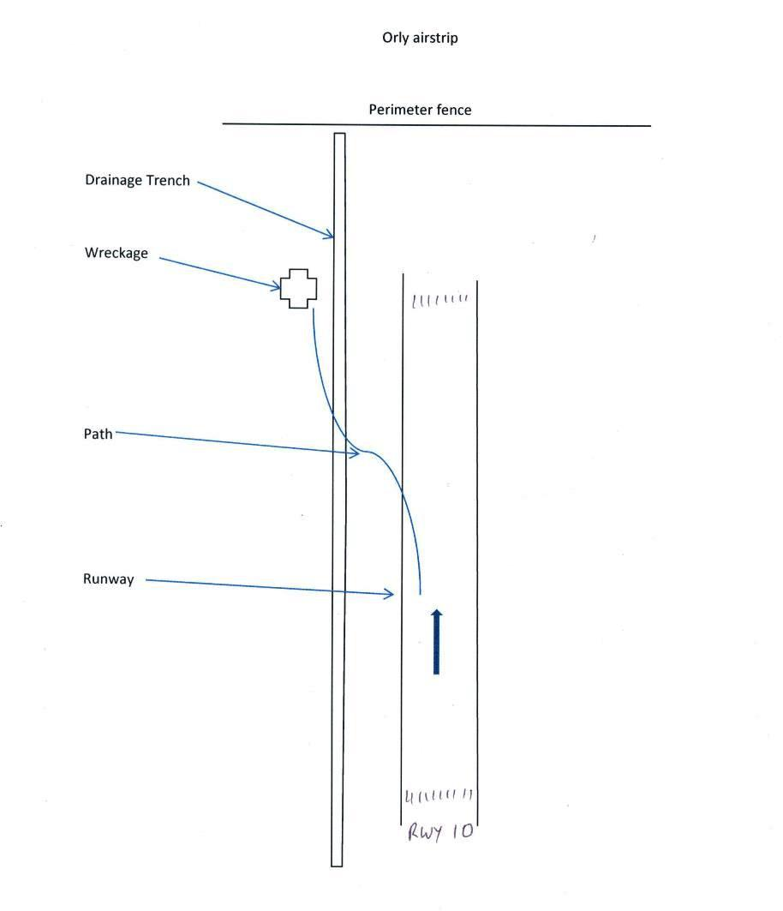
The elevation of the accident site is 5559 feet MSL at standard pressure (1013.2 haP).

Injuries to persons

Injuries | Crew | Passengers | Total
Fatal | 0 | 0 | 0
Serious | 0 | 0 | 0
Minor | 1 | 2 | 3
None | 0 | 0 | 0
Total | 1 | 2 | 3
Summary of all onboard

Damage to aircraft

The aircraft nose landing gear was broken off as a result of hitting the drainage trench while the left main gear was bent rearwards. The left wing lift strut was slightly bent from the impact forces when it flipped over on the backside. There were the internal structural and external surface damages on the fuselage, wings and the tail (vertical stabilizer) sections of the aircraft. The engine cowling was damaged and the engine bearer broken from hard impact with the trench.

Other damage

There was no significant damage on the environment as a result of the accident.

Personnel information

Pilot/Captain

- The pilot was issue with the private pilot license on 5th January 2011 and was valid until 7th December 2012.
- The license had landplanes class and Group ‘A’ aircraft rating.
- The flight radio telephony operator’s license was issued and valid from 5th January 2011 to 4th January 2013.
- Medical certificate (class 1) was issued on 8th December 2011 and was valid until 7th December 2012.
Age | 43 years
Gender | Male
Type and validity of licenses and ratings | PPL
Flying experience (total hours) | 115 hrs
Types flown and hours on type | Cessna 206 and Cessna 172
Hours flown in the last, | -
-24hrs | Nil
-7 days | 1 hr 37 min.
- 90 days | 9 hrs 27 min.
Results of recent training, mandatory and periodic checks | Was checked out on Cessna 172 type on 1 April 2012.
Experience on route and aerodrome/ | Nil
Duty time & rest periods in the 48 hrs prior to the acc. | Sufficient though not applicable for the license holder
Significant medical history and checks | None established

Aircraft information

The aircraft Registration 5Y-BZQ, a Cessna 172N, serial number 17273449 was manufactured by Cessna aircraft company in 11 September, 1979 and was equipped with a Lycoming O-320-H2AD engine serial number L-491-76T.
The aircraft was imported into Kenya under export C of A issued by the US FAA on 26 September 2011. It was sold to proactive agencies ltd of P.O. Box 9135-00300 Nairobi, on 2 February 2012. The aircraft was then registered in Kenya on 27th January 2012. See a copy of registration certificate in appendix E.
The aircraft was issued with a commercial air transport category certificate of Airworthiness on 26th March 2012 and valid for 12 months. See a copy of C of A in appendix D.
The aircraft was re-weighed and a weight and center of gravity schedule issued dated 21st February 2012.
The most recent inspection was performed on 13 February, 2012. At that time, the aircraft had accumulated approximately 10,560 total flight hours.
The engine had a total time of 4622 hrs. and 922 hrs time since overhaul.

Meteorological information

The weather en-route was low Cumulus-Nimbus clouds after the Wilson control zone boundary. At Orly airpark the weather was reported as overcast with Visual Meteorological Conditions (VMC) prevailing much of the morning. The Ceiling (Cloud base) was about 1000 feet AGL with calm winds. At the time of the crash it was reported that cumulonimbus clouds appeared to be approaching from the southern end of the airstrip (Orly).

Aids to navigation

The aircraft was on a visual flight rules flight (VFR) and was well equipped with all the necessary Navigation instruments for the flight. The Navigation aids were not considered a factor in this accident.

Communications

The aircraft was equipped with the standard Radio Communications equipment. In his communication with the Wilson airport ATCO the pilot had informed the tower on 118.10 MHz frequency that he required assistance in finding direction back to Wilson airport and informed that the airport Transponder equipment was unserviceable therefore were unable to determine the aircraft position.

Aerodrome information

Orly Airpark is located approximately 15 NM south of Wilson Airport (Bearing 180º), 1.5 NM south-east of the village of Ollooloitikoshi in Kajiado County, and east of the Kiserian-Isinya “Pipeline Road”. The aerodrome reference point is located at the threshold of runway 10 at coordinates -01.580160 036.808294 and standing at an elevation of 5560 feet AMSL.
Runway 10
True Bearing | 102.64º
length | 1172 meters
Width | 16 meters
Slope | 1.3%
Surface type | Asphalt - 115 meters,  Interlocking Bricks - 487 meters,  Murram – 570 meters
Stop way at end of runway | 122 meters

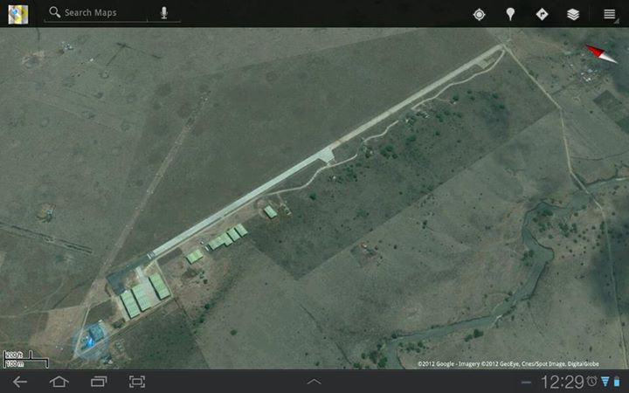

Flight recorders

The aircraft was not equipped with a flight data recorder (FDR) or a cockpit voice recorder (CVR); neither was it required by regulation.

Wreckage and impact information

Medical and pathological information

The pilot and passengers suffered minor injuries from the crash and were treated and discharged from the hospital after thorough examination.

Fire

There was no evidence of fire before the aircraft had impact to the ground surface. An examination of the wreckage at the site and further examination of the wreckage at the storage revealed no indication of a post impact fire.

Survival aspects

The accident occurred after the aircraft made a hard landing. As the aircraft veered off the paved runway with the damaged left main undercarriage, the nose wheel hit the drainage trench running parallel to the runway length, breaking off and resulting in the aircraft tipping over to its back. The impact occurred at a relatively moderate aircraft speed and the resultant stoppage impact caused minor injuries to the occupants.

Tests and research

There were no tests and research carried out and was not considered necessary for this accident.

Organizational and management information

Proactive Agencies ltd that owned the aircraft is a registered company under a certificate of incorporation issued on 4th December 2008. An air service license no. KCAA/LAS/0915 valid for 1 year was issued to the company on 16th November 2011, to operate for hire and/or reward a non-scheduled air service pax/freight services. The air service license was issued for Cessna 150 and 172 type aircraft from Wilson airport base. A copy of the Air service License is in appendix C.

Additional information

The aircraft engine was reassembled at a KCAA approved AMO facility (K/AMO/L/042) on 28th January 2012. Inspection check 1 maintenance was carried out in accordance with an approved maintenance schedule ref TP&ML/LAMS/012.
The 2 passengers were picked from their hotel by the company agents at 7:30 am local time and driven to Wilson airport. It emerged that the passengers were not given passenger safety briefing by the pilot when they boarded the aircraft for take off at 9:30 am. After about 45 minutes into the flight the pilot informed the passengers that they were now returning back to Wilson airport because of very ‘heavy weather’ in Masai Mara. After about 1 hour the pilot appeared to be disoriented according to the passengers and requested for (Transponder) directional assistance from Wilson tower. The tower responded that their system was inoperative, according to the pilot. The pilot then saw the airstrip and decided to land the aircraft after making a single circuit. The approach was fast and steep resulting in the aircraft hard landing and ‘ballooning’ 4 – 5 times before veering off to the side of the runway and hitting the drainage trench, then tipping over to its back.
The aircraft flap setting at the site indicated zero and the fuel selector was on “Both tanks”. The aircraft Hobbs meter read 1846.9 Hrs. while the engine Tachometer reading was 573.3 Hrs at the time of the crash. The last documented readings at the company a/c authorization records on 30 March 2012 were 1838.4 hrs and 573.3 hrs for Hobbs and Tachometer respectively (see a copy of authorization sheet in Appendix B). The pilot’s personal flying logbook records indicate that he did 1hr 37min check out flight on the same aircraft on 1 April 2012 (see a copy of log book in appendix G). The remaining total time flown including the ill-fated flight is approximately 7.0 hrs and 5.7 hrs on Hobbs and tachometer respectively. This indicates a less meticulous flight records keeping by the operator.
During the interview session the pilot mentioned that the previous day (Sunday) he performed training on circuits and did stalls & emergency at the local training area (Wilson).
At the site of the crash about 70 litres of AVGAS fuel was drained from the tanks notwithstanding the amount that leaked when the aircraft remained in an upside down position. At the filling of the flight plan the endurance was indicated as 5 hrs. (See a copy of the flight plan in appendix A).

Useful or effective investigation techniques

There was no useful investigation techniques employed for this accident.

ANALYSIS

An AOC is granted by the KCAA to an aircraft operator to allow it to conduct commercial flight operations within the specified conditions. The operator is required to have personnel, assets and systems in place to ensure the safety of its employees and the general public for the scope of the intended flight operations.
In an interview with the passengers it emerged that the operator had charged them for the charter flight but used a different company (see copies of the payment receipts in appendix F). The operator was not authorized to carry out the commercial flight operation without the certification (AOC) as required in the Kenya Civil Aviation regulations.

CONCLUSIONS

Findings

- The aircraft was appropriately certificated for commercial operations.
- The maintenance records indicated that the aircraft was certified, equipped and maintained in accordance with existing regulations and approved procedures
- The passengers were not briefed on safety and emergency prior to the flight.
- The pilot did not assist in the evacuation of passenger to safety after the accident.
- The pilot was not qualified and appropriately licensed to conduct the commercial flight.
- The operator was not authorized to carry out the commercial activity without the air operator certification as stipulated in the regulations.

PROBABLE CAUSE

The probable cause of the accident was loss of control of the aircraft by the pilot after a hard landing which damaged the aircraft left main undercarriage.

Contributing factors

- The pilot did not have a weather update enroute and had no adequate preparation for such flight. In the process the pilot got disoriented directionally as a result of scattered low clouds.
- The Wilson airport tower was unable to assist the pilot due to inoperative ground transponder equipment.
- The pilot had insufficient handling experience on the type of aircraft.

SAFETY RECOMMENDATIONS

1. Kenya Civil Aviation Authority to monitor and increase oversight surveillance on operators to ensure safe operations of aircraft within the prescribed procedures.
2. KCAA to ensure serviceability of ground transponder equipment at all times during airport operations.
3. Proactive Agencies Ltd to ensure Safe operations by adhering to their AOC certification requirements when conducting commercial operations.
APPENDICES

Appendix A - FLIGHT PLAN
Appendix B - FLIGHT AUTHORIZATION
Appendix C - AIR SERVICE LICENSE
Appendix D - CERTIFICATE OF AIRWORTHINESS
Appendix E - CERTIFICATE OF REGISTRATION
Appendix F - CHARTER PAYMENT RECEIPTS

APPENDIX A

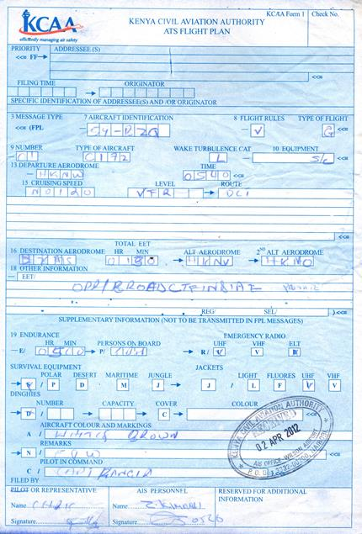

APPENDIX B

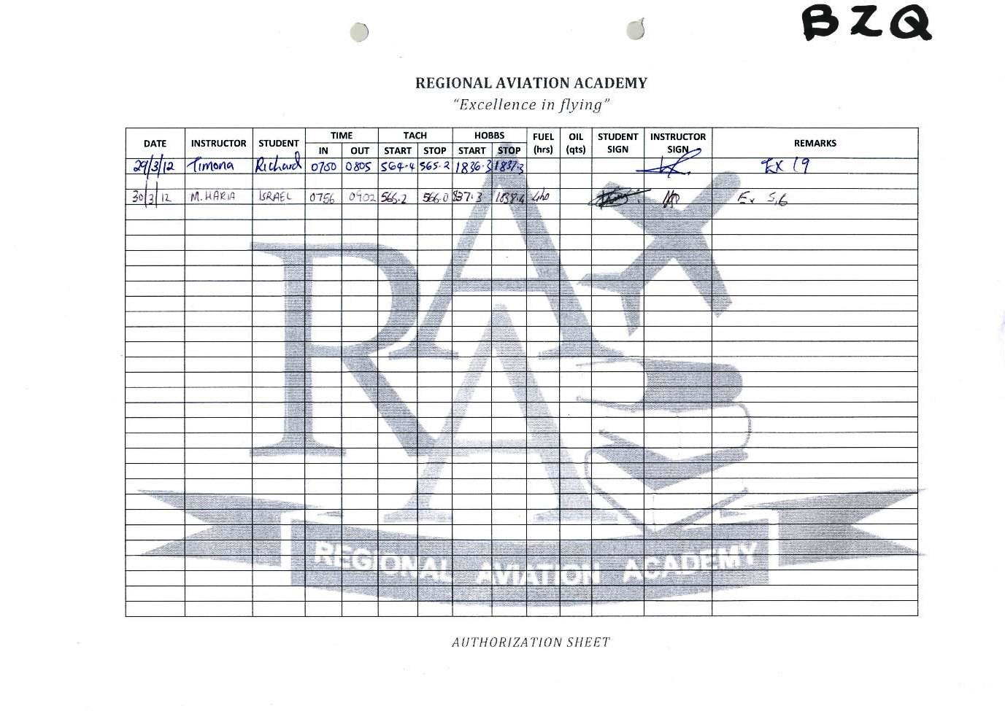

APPENDIX C

APPENDIX D

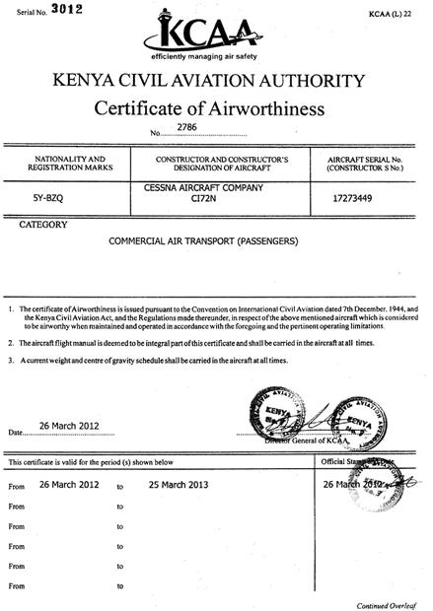

APPENDIX E

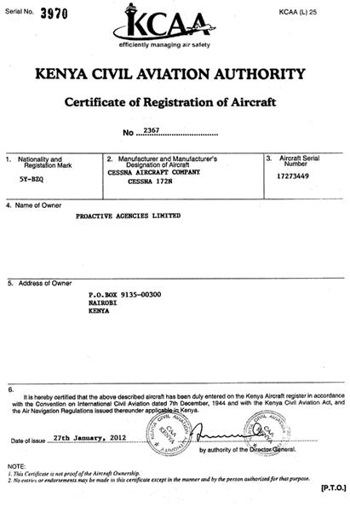

APPENDIX F

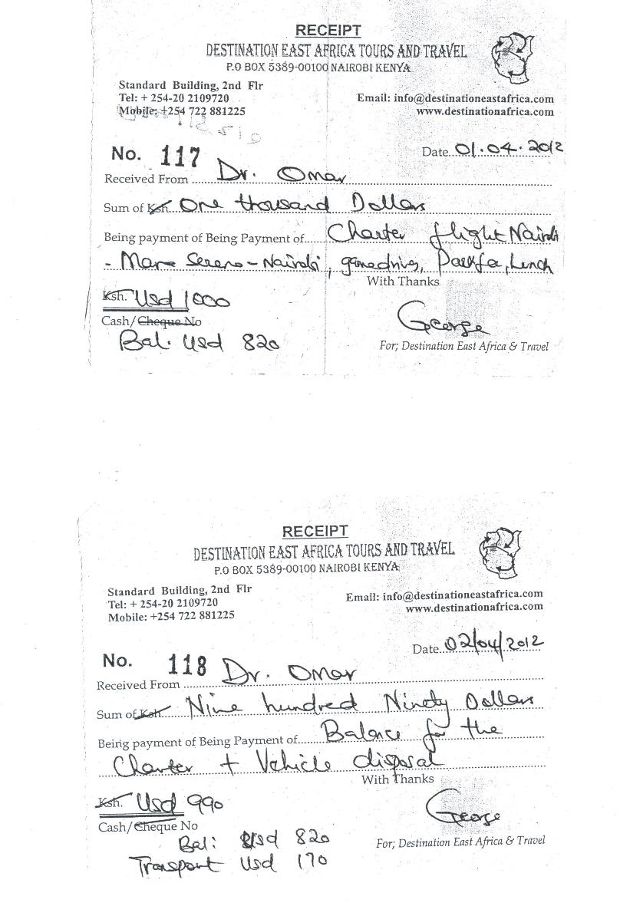

APPENDIX G

