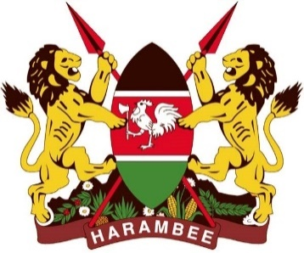

MINISTRY OF TRANSPORT, INFRASTRUCTURE, HOUSING, URBAN DEVELOPMENT AND PUBLIC WORKS
STATE DEPARTMENT FOR TRANSPORT

AIR ACCIDENT INVESTIGATION
PRELIMINARY REPORT

OPERATOR : West Rift Aviation
AIRCRAFT TYPE : Cessna 172M
MANUFACTURER : Cessna Aircraft Company
YEAR OF MANUFACTURE : 1972
AIRCRAFT REGISTRATION : 5Y-CFQ
AIRCRAFT SERIAL NUMBER : 17262795
DATE OF REGISTRATION : 12 March 2015
NUMBER AND TYPE OF ENGINE : One (avco) Lycoming
DATE OF OCCURRENCE : 2 December 2018
LAST POINT OF DEPARTURE : Wilson Airport
POINT OF INTENDED LANDING : Wilson Airport
TIME OF OCCURRENCE : 1804 hours Local Time (LT)
LOCATION OF OCCURRENCE : Wilson Airport
TYPE OF FLIGHT : Training
NUMBER OF PERSONS ON BOARD : One (1)
INJURIES : None
NATURE OF DAMAGE : Broken Nose wheel fork
CLASS OF OCCURRENCE : Incident
PIC FLYING EXPERIENCE : 42 hours as at 02/12/2018
Times given in this report are Coordinated Universal Time (UTC)
East African Local Time is UTC plus 3 hours.

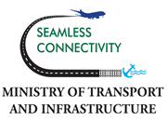
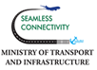

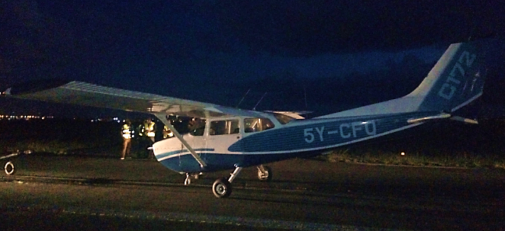

The C172M, 5Y-CFQ on the runway after the incident

REMARKS
On 2nd December 2018 at 1831hours, the Air Accident Investigation Department was notified of a serious incident at Wilson Airport, Nairobi by the Air Traffic Control Tower. The incident involved a Cessna 172M of registration 5Y-CFQ operated by West Rift Aviation. During a landing on runway 07 at Wilson airport, the aircraft’s nose wheel fork got damaged resulting to a nose over of the aircraft and subsequent propeller contacting the runway surface.

The student pilot who had 42hours of flight experience had been conducting circuits with his instructor. The student was cleared to conduct solo circuits, and on the second solo flight of the day the student reported a smooth roll after landing with the aircraft hitting a small pot hole on the runway after the threshold with the nose wheel. The pilot further reported that the aircraft ballooned and on the second contact with the runway, the nose wheel detached from the nose fork with the aircraft coming to a stop at the intersection of runway 07 and taxiway B.

The aircraft nose wheel assembly separated from the nose landing gear attachment resulting to broken nose wheel fork, with slightly curled propeller blades.
There were no injuries reported as a result of this occurrence.
The investigation is in progress.
Fredrick Kabunge
Investigator –In- charge
07 December 2018

