MINISTRY OF TRANSPORT, INFRASTRUCTURE, HOUSING AND URBAN DEVELOPMENT

AIR ACCIDENT INVESTIGATION

PRELIMINARY REPORT

OPERATOR: Penial Air

AIRCRAFT TYPE/MANUFACTURER: Cessna 208/Cessna Co. USA
YEAR OF MANUFACTURE: 1996

AIRCRAFT REGISTRATION: 5Y-BNH

AIRCRAFT SERIAL NUMBER: 208B-00385

DATE OF REGISTRATION: 04/12/2012

TYPE OF ENGINE: ONE-PT6-114A

DATE OF OCCURRENCE: 07/10/2017

TIME OF OCCURRENCE: 1230

LOCATION OF OCCURRENCE: Xuddur Somalia

TYPE OF FLIGHT: Commercial

NUMBER OF PERSONS ON BOARD: 8

INJURIES: Nil

NATURE OF DAMAGE: Substantial

CATEGORY OF OCCURRENCE: Accident

PIC’S FLYING EXPERIENCE: TBN

All times given in this report are Coordinated Universal Time (UTC)
East African Local Time is UTC plus 3 hours.
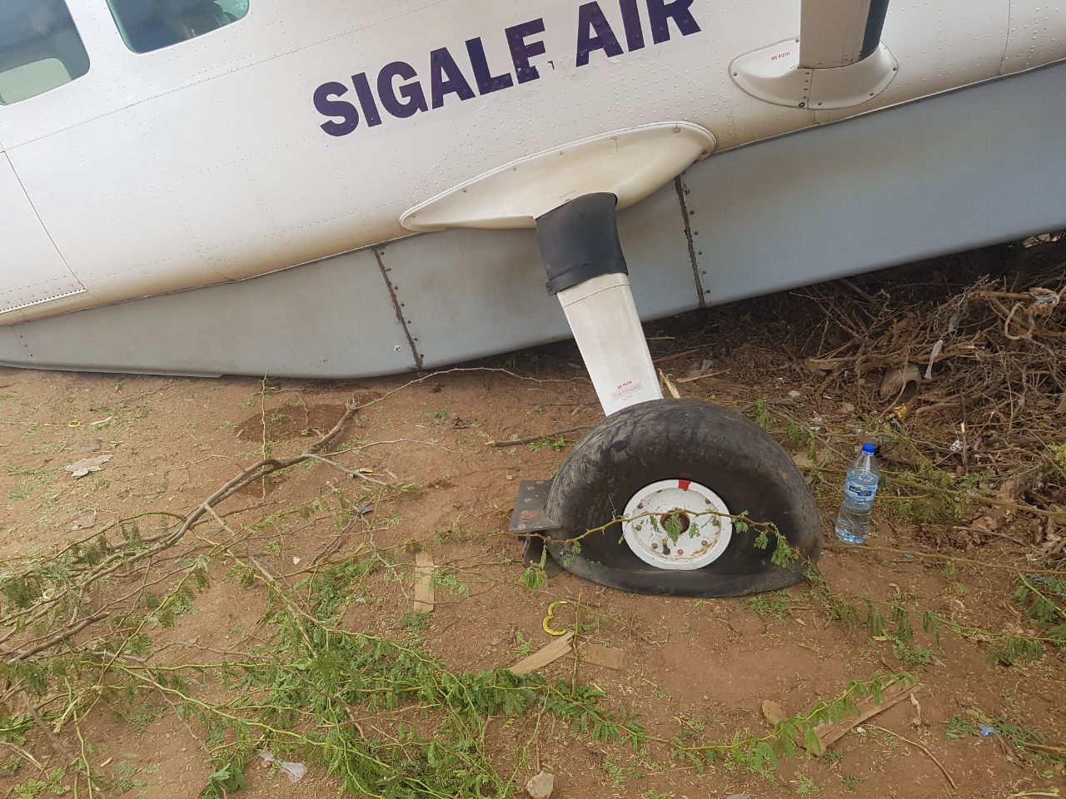
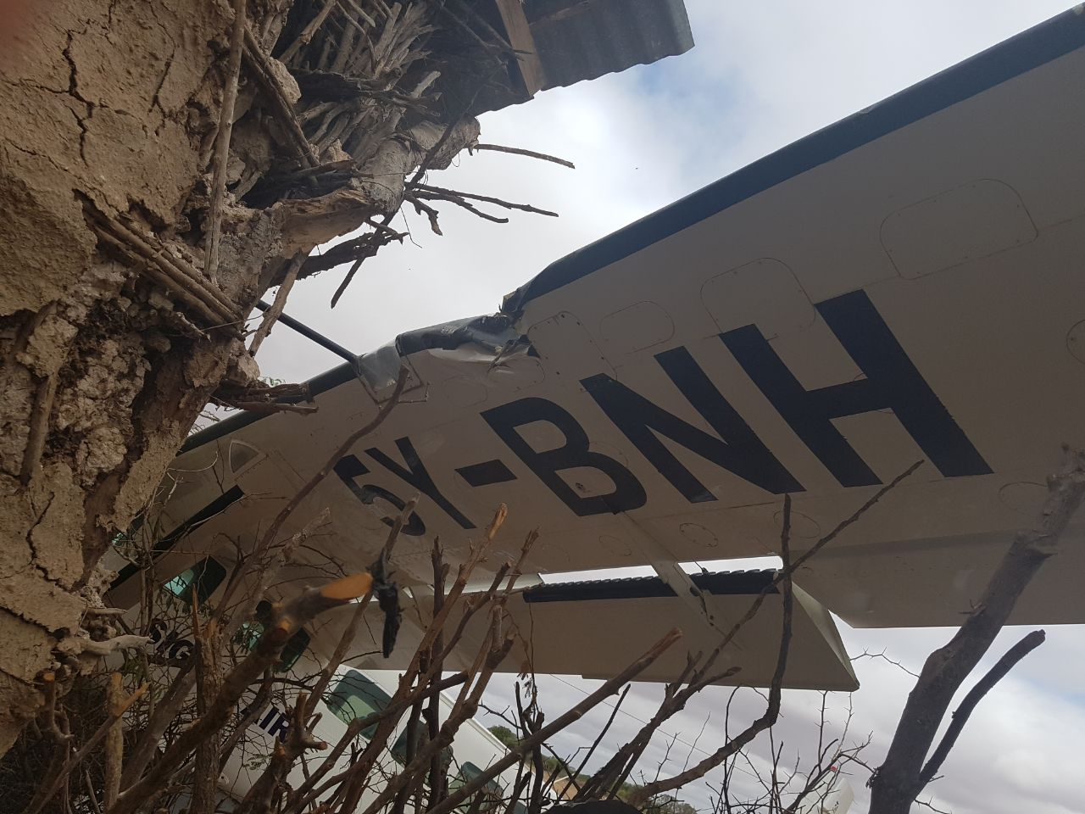

REPORT

On 7th October 2017, the Air Accident Investigation Department of the Ministry of Transport, Infrastructure and Urban Development was notified of aircraft accident involving a Cessna 208 type of aircraft registration 5Y-BNH at Xuddur in Somalia at 1203 hours.

The received report indicated that the aircraft was on a flight from Mogadishu destined to Nairobi Wilson through Baidoa, Xuddur, Elberde, and Wajir. The flight between Mogadishu and Baidoa was uneventful. At 1130 hours, the pilot took off from Baidoa with eight passengers onboard and landed safely at Xuddur at 1203 hours. At Xuddur, four passengers disembarked with their cargo and the pilot picked four other passengers with their cargo. As the pilot was preparing for take-off from Xuddur to Elbede there appeared to be some disagreements among the local agents about the cargo which was onboard the aircraft. The pilot was made to temporary suspend the take-off as the agents tried to sort out their differences. According to the pilot, there seemed to be unclear decision among the agents on whether to allow the pilot to proceed with the take-off or stop as the pilot was instructed to stop twice after being allowed to take off.

A few moments later, the pilot decided to take-off after a group of Somali soldiers, local police, Ethiopian soldiers and the local agents had moved away from the aircraft. As soon as the pilot started taxing the aircraft for take-off two armed men came running brandishing guns towards the aircraft and started firing rapidly at the aircraft as the pilot continued with the take-off. The aircraft had gained some speed when the pilot decided to abort the take-off. As the pilot tried to abort the take-off the aircraft veered off the runway and collided with a building nearby before it stopped. All the occupants exited the aircraft using the rear door. The two front doors were inaccessible after the impact.

Damage
The propeller twisted, a dent on the port wing, the landing light shattered, and the two main landing tires deflated as a result of the bullet holes on both the tyres and the aircraft fuselage. A bullet was also found lodged in the right main landing gear brake caliper.

No further Annex 13 investigations will be conducted on the occurrence

CHIEF INVESTIGATOR OF ACCIDENTS
12 October 2017

