

MINISTRY OF TRANSPORT, INFRASTRUCTURE, HOUSING AND URBAN DEVELOPMENT
STATE DEPARTMENT OF TRANSPORT
AIR ACCIDENT INVESTIGATION DEPARTMENT
PRELIMINARY REPORT
OPERATOR : Etihad Airways
AIRCRAFT TYPE/ MANUFACTURER : Airbus A320-232 / Airbus
YEAR OF MANUFACTURE : 2014
AIRCRAFT REGISTRATION : A6-EIX
AIRCRAFT SERIAL NUMBER : 6134
DATE OF REGISTRATION : 24 June 2014
DATE OF OCCURRENCE : 06 January 2018
TIME OF OCCURRENCE : 1357 hours
LOCATION OF OCCURRENCE : Jomo Kenyatta International Airport (JKIA)
(Parking Bay 8 (S011943.82, E0365527.35))
DEPARTURE AERODROME : JKIA (HKJK)
DESTINATION AERODROME : Abu Dhabi Int’l Airport (AUH)
TYPE OF FLIGHT : Commercial Air Transport (Passenger)
FLIGHT № : EY642
NUMBER OF PERSONS ON BOARD : One hundred and forty one (141)
INJURIES : None
NATURE OF DAMAGE : Crack and dent on the rear outboard right engine
cowling
CATEGORY OF OCCURRENCE : Ground Incident
GROUND HANDLING AGENT : Swissport Int’l Limited
PILOT IN COMMAND (PIC) : TBD
PIC FLYING EXPERIENCE : TBD
Times given in this report are East African Local Time
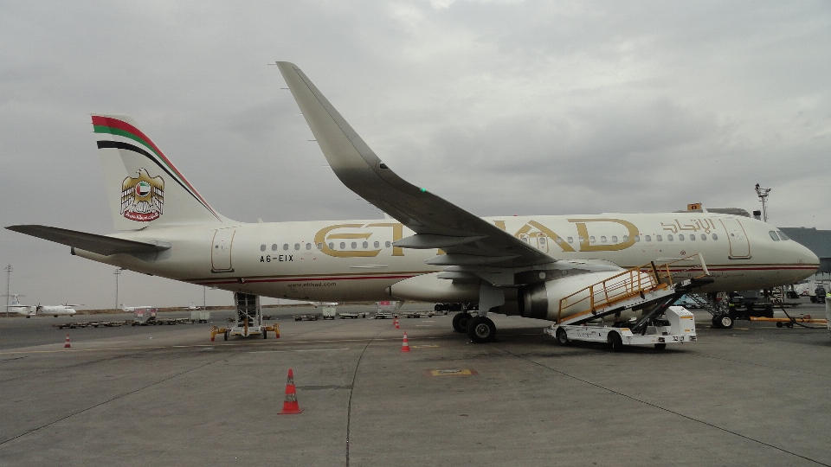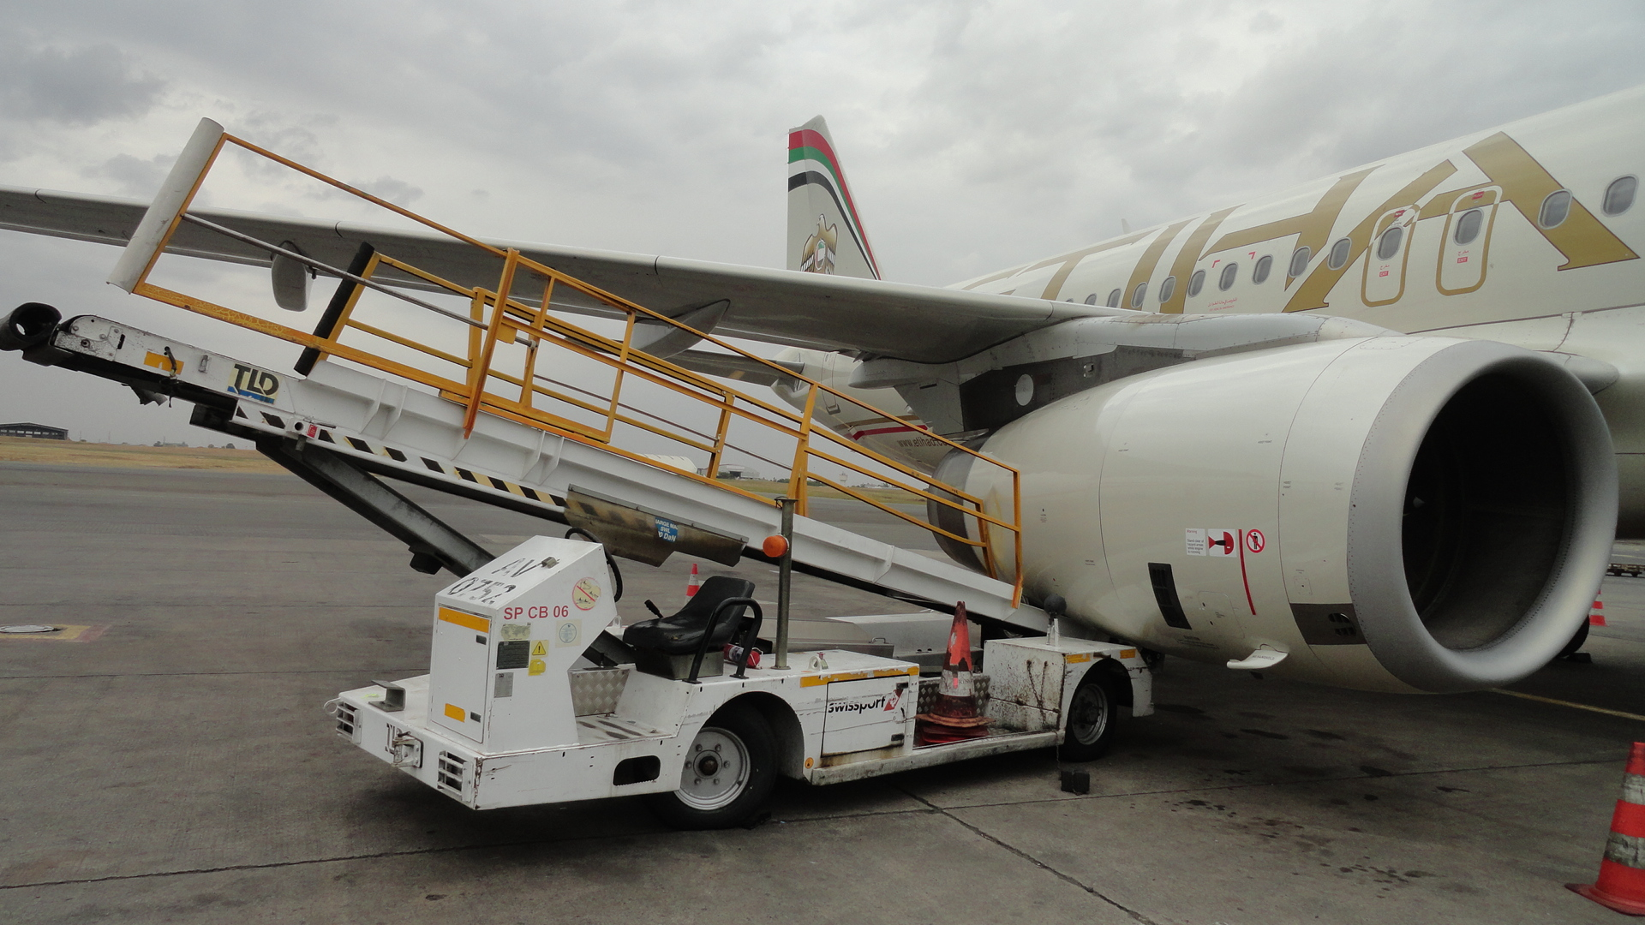
REMARKS
On the afternoon of 6 January 2018, the Air Accident Investigation Department was notified of a ground incident at JKIA by the Air Traffic Control (ATC) Tower. The incident involved an Airbus A320-232 of registration A6-EIX (EIX) operated by Etihad Airways. A conveyor belt loader operated by Swissportn Int’l Limited collided with the aircraft right engine during pre-departure preparations.
EIX arrived from AUH on 6 January 2018 at 1308 and was scheduled to depart the same day at 1405 for AUH. Upon arrival, EIX was parked at Bay 8 of Apron 1, JKIA. A conveyor belt loader № SPCB 06 was then positioned at the aft cargo compartment № 3/4 to facilitate offloading of arriving baggage and cargo and the eventual loading for departure. At approximately 1350, loading of the aft cargo compartment was reported to have been almost complete only awaiting loading of some extra baggage from the forward cargo compartment. At 1357, the conveyor belt loader № SPCB 06 reversed, without an operator, from its stationary position at the aft cargo compartment, colliding with a baggage trolley which was located approximately 6 meters away from the aircraft, aft of the conveyor belt loader. After impacting the trolley, the direction of movement of the conveyor belt loader changed by about 180° and it then headed towards the right engine. The conveyor belt loader SPCB 06 impacted on the right engine resulting in a crack and dent on the rear outboard cowling.
Passenger boarding was reported to have been ongoing but almost complete at the time of occurrence. There was no injury reported as a result of the ground collision incident. Visible damage on the right engine was limited to the rear outboard cowling. The flight was cancelled after assessment of the damage.
The investigation is in progress.

Rufus Mutwol
Investigator-In-Charge
19/01/2018

