MINISTRY OF TRANSPORT, INFRASTRUCTURE, HOUSING, AND URBAN DEVELOPMENT
STATE DEPARTMENT OF TRANSPORT
AIR ACCIDENT INVESTIGATION
PRELIMINARY REPORT

OPERATOR: Safari Express Cargo Ltd

AIRCRAFT TYPE/MANUFACTURER: Fokker F27 Mk600/Fokker Dutch Ac.

YEAR OF MANUFACTURE: 1967

AIRCRAFT REGISTRATION: 5Y-FMM

AIRCRAFT SERIAL NUMBER: 10318

DATE OF REGISTRATION: 14/07/2016

TYPE OF ENGINE: MK532-7 Rolls Royce

DATE OF OCCURRENCE: 03/06/ 2017

TIME OF OCCURRENCE: 0820

LOCATION OF OCCURRENCE: Garbaharey Airport Somalia
(N 03º19’26.1” E 42 º12’48.9”)

TYPE OF FLIGHT: Cargo

NUMBER OF PERSONS ON BOARD: 3

INJURIES: Nil

NATURE OF DAMAGE: Substantial

CATEGORY OF OCCURRENCE: Accident

PIC’S FLYING EXPERIENCE: ATPL 3600 Hours

All times given in this report are Coordinated Universal Time (UTC)
East African Local Time is UTC plus 3 hours.

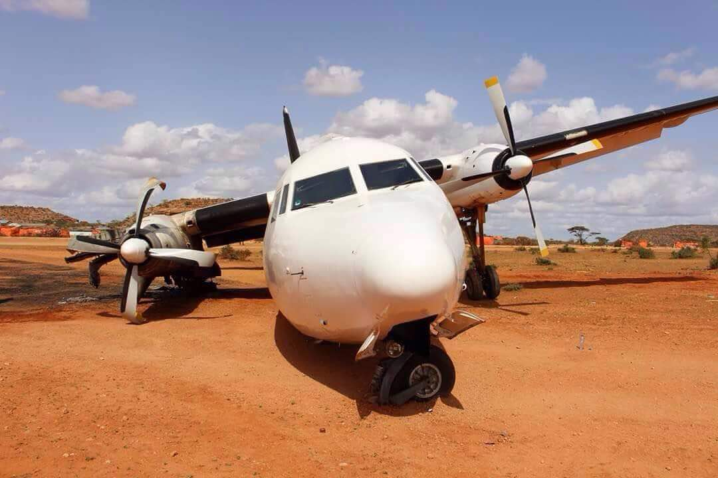
NARRATIVE
On 3rd June 2016 at 1120 hours, a Fokker 27/Mk600 registration 5Y-FMM operated by Safari Express Cargo Ltd, courtesy of the WFP was ferrying relief supplies from Mogadishu to Garbaharrey Airport was involved in an accident on landing at the destination airport.
On touch down, the right hand main landing gear collapsed resulting from a collision with an obstacle of approximately 2 meter high on short final approach. The aircraft subsequently had a runway excursion to the starboard side. A segment of the right hand wing contacted the ground and was severed off from the rest of the wing with ensuing fuel spillage and fire. All the four propeller blades of the starboard engine contacted the ground surface and suffered rearwards bends. The fire was however contained before spreading further.
Both CVR and FDR were recovered. AAID-Kenya is contacting appropriate ICAO Annex 13 investigation
Investigation is ongoing

Chief Investigator of Accidents
06/06/2017
_______________________________________________________________________

