MINISTRY OF TRANSPORT, INFRASTRUCTURE, HOUSING, URBAN DEVELOPMENT AND PUBLIC WORKS
STATE DEPARTMENT FOR TRANSPORT

AIR ACCIDENT INVESTIGATION
PRELIMINARY REPORT

OPERATOR/OWNER : David Mutava
AIRCRAFT TYPE : Cessna 172L
MANUFACTURER : Cessna Aircraft Company
YEAR OF MANUFACTURE : 1971
AIRCRAFT REGISTRATION : 5Y-BWE
AIRCRAFT SERIAL NUMBER : 17259613
DATE OF REGISTRATION : 18 April 2017
NUMBER AND TYPE OF ENGINE : One Lycoming 0-320
DATE OF OCCURRENCE : 29 November 2018
TIME OF OCCURRENCE : 0530hours
LOCATION OF OCCURRENCE : Oserangoni Airstrip.
(00º49’16’’ S 036º17’ 76’’ E)
TYPE OF FLIGHT : Private
NUMBER OF PERSONS ON BOARD : Two (2)
INJURIES : None
NATURE OF DAMAGE : Broken left landing gear strut
attachment
CLASS OF OCCURRENCE : Serious Incident
PILOT IN COMMAND : YK-9980-PL
PIC FLYING EXPERIENCE : 202 hours
Times given in this report are Coordinated Universal Time (UTC)
East African Local Time is UTC plus 3 hours.

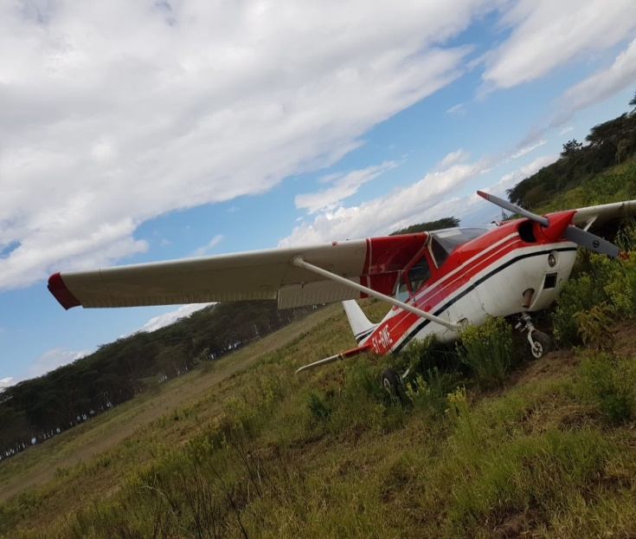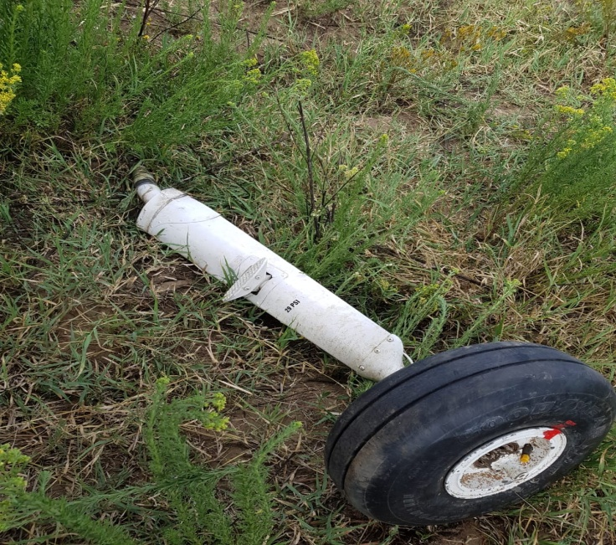

The C172L, 5Y-BWE at the scene of the accident and the detached left landing gear.

REMARKS
On 29 November 2018 at The Air Accident Investigation Department was notified of a serious incident at Oserian farm Naivasha, by the Farm management. The incident involved a Cessna 172 registration 5Y-BWE operated by Mr.David Mutava. During landing, the aircraft’s had an impact with a wild animal, resulting into left landing gear break off and runway excursion.

On 29 November 2018, 5Y-BWE took off from Tatu city with two persons onboard on its way to Oserian with 5hours endurance. The estimated landing time was 0530hours on runway 25 at Oserangoni Airstrip in Naivasha, Nakuru County. The pilot reported not to have notified the airstrip management of his intentions to land on the fateful day. The pilot approached runway 25 at a low level overpass to check the runway condition and the windsock. He spotted dozens of warthogs and the windsock indicated that winds were calm. Subsequently, he proceeded to make a low level overpass to clear the airstrip and later climbed to approach runway 07. The pilot then proceeded to final approach on runway 07 and noticed a warthog in the scrubs at the side of the runway, he set the flaps at 20 degrees for landing but on short final approach he decided to make another low level overpass to make sure the runway was clear. The plane later landed on runway 25, at airspeed of approximately 40Kts but half way down the runway a warthog bolted out from the scrub at the side of the runway impacting left undercarriage. The aircraft veered off to the left coming to a stop about 50meters from the runway

The aircraft was reported to have broken the left landing gear strut attachment due to the impact forces on landing. No one was injured during the occurrence.

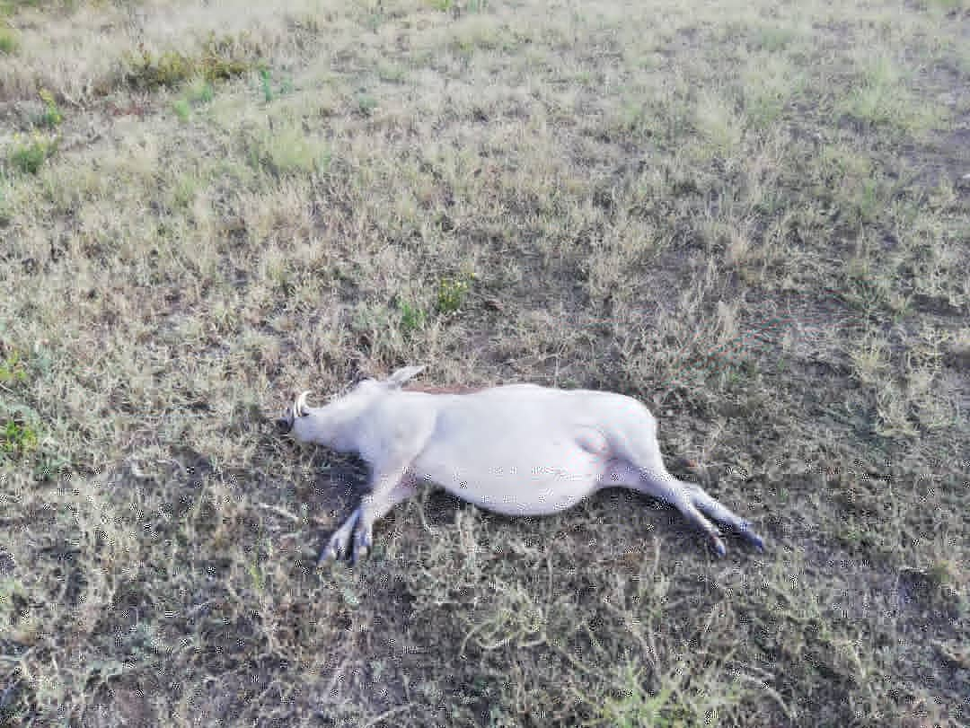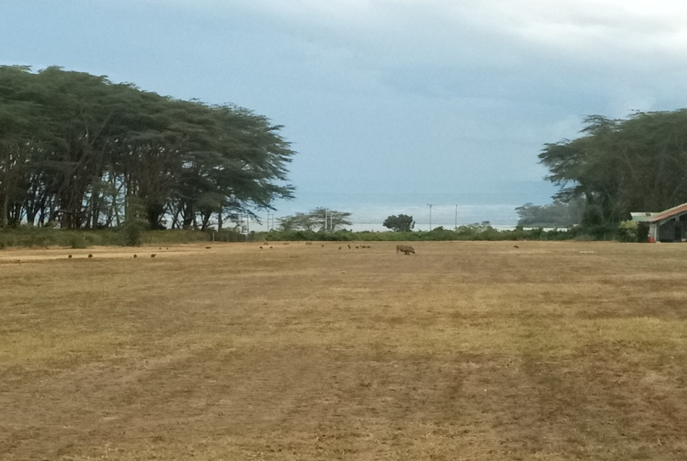
Warthog that impacted the aircraft at the accident site and the airstrip when AAID investigators went to the airstrip.

OSERANGONI AIRSTRIP
Although the airstrip in unmanned, Oserangoni is a fenced and gated airstrip located on the shores of Lake Naivasha. There are flower farms and resorts in the area. The airstrip is located on a wildlife corridor on both sides and the corridor allows animals to be able to access the Lake Naivasha. The airstrip has not had any previous occurrence reported due to the agreement the operators have with the management and pilots. During approach/departure, take-off/landing, the airstrip management is notified to make sure the runway and the vicinity is safe and clear of the wild animals.
The management has not reported any problem with any of the other animals apart from the numerous warthogs which prefer open spaces for feeding. They avoid the shrubs in fear of predators and are able to burrow under the fences thus they are always on the airstrip. The management has contacted the Kenya Wildlife Services on several occasions to get rid of the large and fast growing population but they keep on breeding. When AAID investigators visited the airstrip there were warthogs grazing at the middle of the airstrip.
SAFETY ACTION
Whether or not the AAID identifies safety recommendations in the course of an investigation, the relevant organizations may proactively initiate safety action in order to reduce their safety risk.

RECOMMENDATIONS
- Airstrip management should ensure that they are notified of all aircraft using to ensure the airstrip is cleared.
- The Airstrip management should work with KWS and Kenya Airport Authority wildlife management departments, to ensure a permanent solution is reached in regard to the wild animals that use the airstrip as a corridor to be able to access the Lake Naivasha.
Fredrick Kabunge
Investigator -In- charge
10 December 2018

